NJTPA Complete Streets Demonstration Library
Request Form

INSTRUCTIONS
The North Jersey Transportation Planning Authority (NJTPA), in partnership with the Hudson Transportation Management Association (Hudson TMA), operates a Complete Streets Demonstration Library for the purpose of loaning materials to municipal governments and other partners to implement temporary demonstration projects on and adjacent to publicly accessible roads and other transportation facilities.
Complete this form to request materials. Text fields will automatically expand as you type, so enter as much information as necessary. When complete, save this document as a new file. Municipalities and counties should apply to the NJTPA with a Cc: to the transportation management association (TMA) for your region listed below. Include any relevant attachments such as plans, diagrams, maps, or correspondence, if available.
Submit this request form to:
- The NJTPA at demonstration@njtpa.org and
- Cc: the TMA contact for your region:
TMA | COUNTY | PHONE | EMAIL
Avenues in Motion | Morris  Sussex  Warren  Western portions of Passaic and Essex | 973-267-7600 | info@avenuesinmotion.org
Cross County Connection TMA | Atlantic  Burlington  Camden  Cape May  Cumberland  Gloucester  Salem | 858-596-8228 | ccctma@driveless.com
EZ Ride | Bergen  Union  Essex  Monmouth  Eastern portions of Passaic | 201-939-4242, toll free 866-208-1307 | info@ezride.org
goHunterdon | Hunterdon | 908-788-5553 | info@gohunterdon.org
Greater Mercer TMA | Mercer  Ocean  Montgomery Township in Somerset County | 609-452-1491 | tma@gmtma.org
Hudson TMA | Hudson | 201-324-6222 | info@hudsontma.org
Keep Middlesex Moving | Middlesex | 732-745-4465 | programs@kmm.org
RideWise | Somerset, except for Montgomery Township | 908-704-1011 | staff@ridewise.org

Request Form
Name: Click or tap here to enter text. | Organization: Click or tap here to enter text.
Email: Click or tap here to enter text. | Phone: Click or tap here to enter text.

Project title: Click or tap here to enter text.
Location: Click or tap here to enter text.
Project Type (select all that apply): ☐ Bike Lane ☐ Crosswalk ☐ Curb Bump-Out ☐ Intersection Mural ☐ Parklet ☐ Pedestrian Refuge Island ☐ Sidewalk Extension ☐ Slow Street Treatment
Describe your project:
Click or tap here to enter text.
☐ Plans, diagrams and/or maps are attached
Installation date: Click or tap here to enter text. | Removal date: Click or tap here to enter text.
Desired pickup date: Click or tap here to enter text. | Desired return date: Click or tap here to enter text.
How will you transport the materials? (The borrower is responsible for picking up and returning the materials.)
Click or tap here to enter text.
Who are your partner organizations for this project, if any?
Click or tap here to enter text.
How will you conduct outreach and advertise the project to the community?
Click or tap here to enter text.
Which jurisdiction(s) operate the roadway?  ☐ State  ☐ County  ☐ Municipal  ☐ Other: Click or tap here to enter text. | How will you obtain jurisdiction(s) approval?  Click or tap here to enter text.
Jurisdiction(s)/owner(s) contact information (if different from applicant):
Click or tap here to enter text.
How will you document the project? (Media, user counts, photographs, surveys, etc. Borrowers are requested to provide documentation of the project to the NJTPA.)
Click or tap here to enter text.

Question and notes:
Click or tap here to enter text.

MATERIALS REQUEST – INDICATE QUANTITY
The quantity of materials may vary. Please be sure to check the availability of materials with demonstration@njtpa.org
ITEM | DIMENSIONS | QUANTITY AVAILABLE | REQUESTED QUANTITY
TRAFFIC CALMING
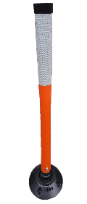  Delineator: Flexible Post  Used for longer demonstration projects. This delineator is bolted to the ground, or epoxy may be used to help keep it upright. This delineator will not stand on its own.  Can be used for bike paths, median islands, curb extensions/plazas, and roundabouts. | 36" | 355 | Click or tap here to enter text.
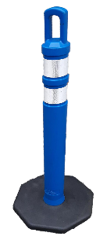  Delineator: Free-Standing with Base  Used to create short-term post-style barriers. Can be used for bike paths, median islands, curb extensions/plazas, and roundabouts.  These delineators are not bolted to the ground, but epoxy may be used with them to help reduce delineators from being knocked down. | 36" | 120 | Click or tap here to enter text.
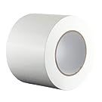  Duct Tape  Typically used for one-day projects. Can be used to help demarcate pavement patterns. Used for bike lanes, pedestrian crossings, curb extensions, plazas, and roundabouts.  It is best to sweep or power-wash the street before applying the tape. | White:  Green  1.88“ X 60 ft | 5  23  15 | Click or tap here to enter text.
  4" width x 60 ft
  4" width x 165 ft
Parking Stops  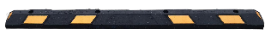  Low, mountable cubs that can be bolted to the pavement and used as a barrier element.  Parking stops can be used for bike lanes,  roundabouts, etc. | L x W x H  72 x 6 x 4" | 30 | Click or tap here to enter text.
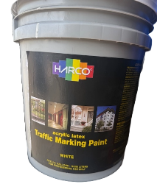  PAINT: Acrylic Traffic Paint (white, yellow)  Acrylic water-based paint. This paint should be used for longer-term projects and is more appropriate for curb extensions or plazas. | 5 gallons  1 gallon  5 gallons = 600 sf, 1800 linear ft | 12 White, 14 yellow | Click or tap here to enter text.
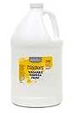  Paint: TEMPERA  A more temporary paint that can last from one day to a month. Tempera paint can be applied straight from the bottle, or thinned with a mixture of cornstarch and water (1:1 ratio). This paint is sensitive to weather conditions.  Used to create bike lanes, pedestrian crossings, curb extensions, plazas, roundabouts, etc. | 1 gallon  1 gallon = 120 sf, 360 linear ft | White: 40  Yellow: 36  Red: 28  Orange: 32  Green: 12  Blue: 43  Brown: 12 | Click or tap here to enter text.
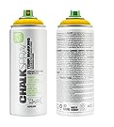  PAINT: Spray Chalk  Temporary marking chalk/paint that can be used to fill in bike lane and crosswalk makings.  To get a long, consistent demarcation, use an athletic field striper to apply the spray chalk. Markings can last from one week to one month depending on it spray-varnish is used as well. | 15 oz can:  600-800 linear ft  25 sq ft | White: 57  Yellow: 33  Blue: 20  Pink: 20 | Click or tap here to enter text.
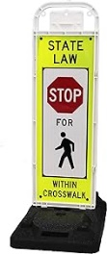  Pedestrian Crossing IN CROSSWALK SIGN  High-visibility crosswalk signs can be placed in crosswalks to increase the visibility of pedestrian crossing areas to drivers. | U-frame &  37 lb. U base | 4 | Click or tap here to enter text.
Plastic Barriers  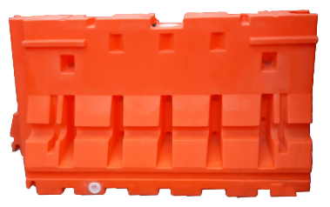  Barriers that can be filled with water or sand to create a barrier. If filled – this should be used for a longer demonstration project.  Barriers can be used for separated bike lanes and plazas. | L x W x H  72 x 24 x 24” | 15 | Click or tap here to enter text.
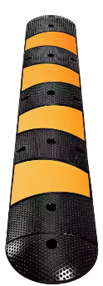  speed hump  More material specs here | 12.2 in. x 6.07 ft. | 5 | Click or tap here to enter text.
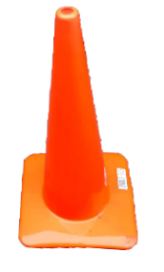  Traffic Cone  Used as a barrier element for a short-term demonstration project. Can be used for bikeways, median islands, curb extensions/plazas, and roundabouts. | 28" | 150 | Click or tap here to enter text.
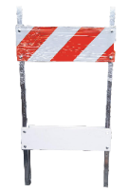  Traffic Control Barricade  Can be used for temporary street closures or to post temporary signs. | 24" | 13 | Click or tap here to enter text.
  Traffic Tape (foil backed – white, yellow)  Reflective, non-slip traffic tape. Tape is easy to apply and can be used to demarcate bike lanes, pedestrian crossings, curb extensions, plazas, and roundabouts. | 4" x 50’  Yellow: 4” x 50 yds | White: 30 rolls  Yellow: 28 rolls | Click or tap here to enter text.
SIGNS AND STENCILS
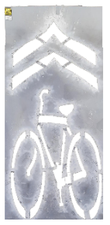  Bicycle SHARROW  Government/contractor stencil | 10’ x 4’ | 6 | Click or tap here to enter text.
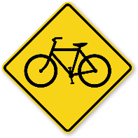  Bike Signs  Can be used when a temporary bike lane is installed to let road users know the area will be frequented by cyclists. | 24" | 10 | Click or tap here to enter text.
  CROSSHATCH  Can be used within curb bump-out, daylighting, or no parking areas. | 24” x 90”  (2 ft x 7.5 ft) | 5 | Click or tap here to enter text.
letters and numbers  Can be used to assist with asphalt art purposes and wayfinding | 6” |  | Click or tap here to enter text.
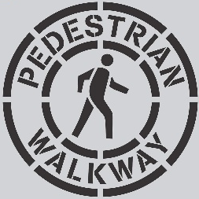  PEDESTRIAN WALKWAY  Can be used along sidewalks and before crossing areas.  Best used with spray chalk/paint | 18”  (1.5 ft) | 5 | Click or tap here to enter text.
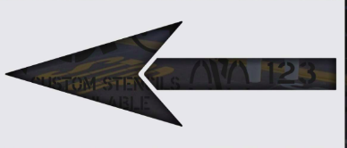  STRAIGHT ARROW  Can be used along sidewalks and before crossing areas. | 114'' x 38''  (9.5 ft x 3.2 ft) |  | Click or tap here to enter text.
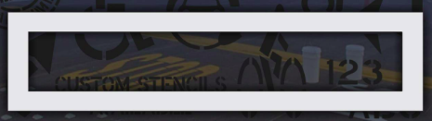  STOP BARS  To be used to add or touch up an existing stop bar. | 72” x 12”  6 ft x 1 ft | 10 | Click or tap here to enter text.
sunflower  Stencils that can be used along sidewalks or inside of curb extensions. | 6” | 15 | Click or tap here to enter text.
TOOLS
Asphalt Scraper  Scraper can be used to help remove epoxy adhesive from pavement.  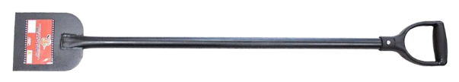 | NA | 2 | Click or tap here to enter text.
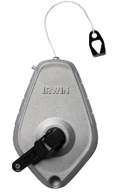  Chalk Line  Helps create straight guidelines for striping/paint markings | 100’ | 15 | Click or tap here to enter text.
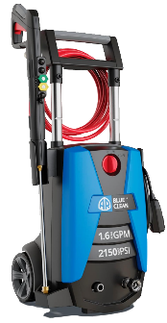  Electric Power Washer  Used to assist with project cleanup. For the best results, use soap. Connects to a garden hose. | NA | 1 | Click or tap here to enter text.
  Epoxy  *Used with flexible delineator posts  More material specs here | NA | 20 | Click or tap here to enter text.
  Heavy Duty Outdoor Push Broom  Used to clean debris from streets and or sidewalks before applying paint. | 18” | 3 | Click or tap here to enter text.
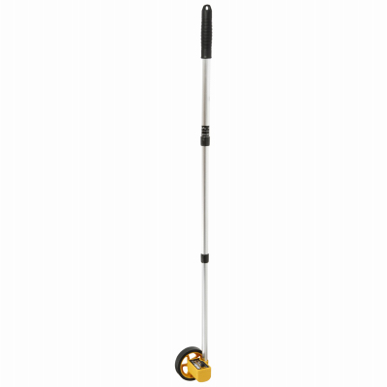  Measuring Wheel  Long-range measurement tool. 5-digit, easy-read magnified counter accurately measures up to 9,999 feet | 17”-42” | 3 | Click or tap here to enter text.
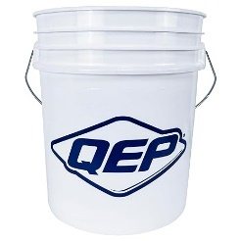  Paint Bucket  Used for mixing and holding paints. Can be used with the paint grid/tray for easy painting straight from the bucket. | 5 gallon | 9 | Click or tap here to enter text.
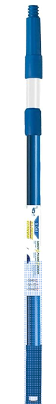  Paint 5’ Extension pole  Used to help extend paint roller for easier street painting. | 5’ | 11 | Click or tap here to enter text.
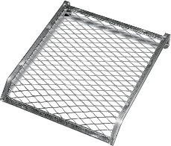  Paint Grid/Tray  Metal paint grid/tray that attaches to a 5-gallon paint bucket. Allows for painting straight from the bucket. | Fits 5-gallon bucket | 10 | Click or tap here to enter text.
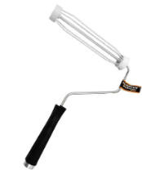  Paint Roller  Applies paint to asphalt, concrete, and other surfaces. | 9” | 54 | Click or tap here to enter text.
Paint Roller Covers  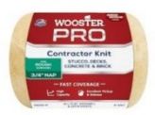  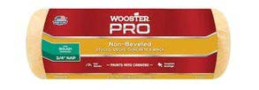  Fabric roller cover to be used with paint roller. | 9” roller  4” roller | 9” - 90  4” - 105 | Click or tap here to enter text.
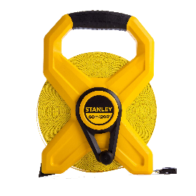  Tape Measure  Assists with laying out measurements of different project elements. | 200' | 2 | Click or tap here to enter text.
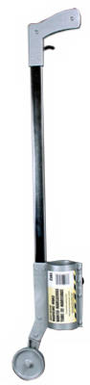  upright spray marking wand  Upright marking wand for use with spray chalk/paint to assist with delineation. | 3’ | 4 | Click or tap here to enter text.
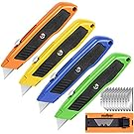  Utility Knife  Great for opening packaging, creating traffic-marking stencils, and cutting traffic tape. | NA | 8 | Click or tap here to enter text.
PLACEMAKING
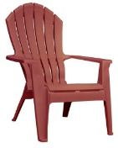  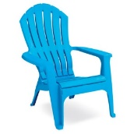  Adirondack Chair  Can be used for placemaking efforts such as parklets and open streets. | 7.35 pounds  32.5 x 30 x 37.5 in | 2 Merlot  2 Pool Blue | Click or tap here to enter text.
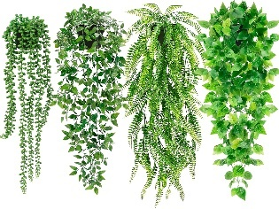  Artificial hanging plants  Four different artificial hanging plants that can be used for placemaking efforts. Plants include String of Pearls, Mandala Vine, Persian Grass Fern, Ivy Vine. | 5 x 5 x 20 in | One, 4 pack | Click or tap here to enter text.
  artificial palm tree  Can be used for parklets and placemaking as well as in curb bump-outs and extensions. | 4’ | 2 | Click or tap here to enter text.
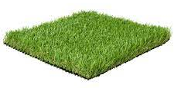  ASTRO TURF MAT (green)  Used to add a sense of greenery to a project. The turf mats may be used for bike lanes as buffer areas, curb extensions, or plazas. | 4' x 6' | 5 | Click or tap here to enter text.
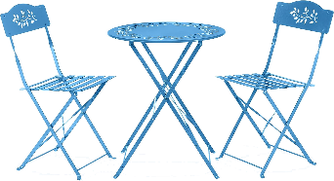  Bistro Table Set  Can be used for parklets and placemaking. | 24” x 24” x 33” | 1 | Click or tap here to enter text.
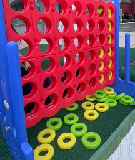  connect 4 - large  Can be used for parklets and placemaking. | NA | 1 | Click or tap here to enter text.
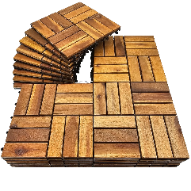  Interlocking Deck Tiles  Can be used for parklets and placemaking. | 24 sf | 2 packs | Click or tap here to enter text.
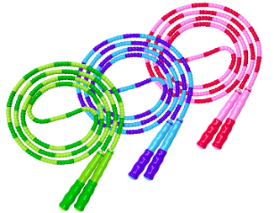  jump rope  Activity to help activate public spaces. |  | Single: 3  Double dutch: 2 pack | Click or tap here to enter text.
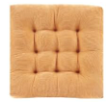  Outdoor Floor Cushion  Can be used for parklets and placemaking. | 22” x 22” | 2 | Click or tap here to enter text.
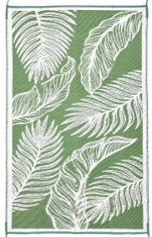  Outdoor Rug  Can be used for parklets and placemaking. | 5’ x 8’ | 1 | Click or tap here to enter text.
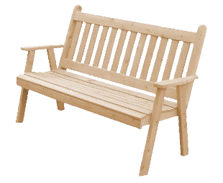  Park Bench  Bench can be used to activate curb extensions, parklets, and plazas. | 4' long  23" w x 28" h | 2 | Click or tap here to enter text.
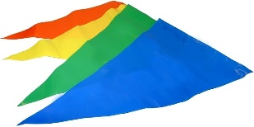  pennet flag (muticolor)  Can be used for parklets and outreach events. | 50’ | 2 | Click or tap here to enter text.
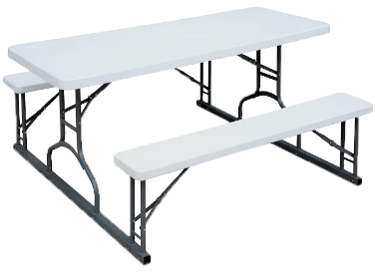  Picnic Table  Can be used to activate curb extensions, parklets, or plazas. | 58" x 30" x  48-72" length | 2 | Click or tap here to enter text.
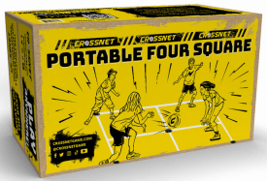  portable four square  Can be used to help activate placemaking efforts. | 12’ x 12’ | 1 | Click or tap here to enter text.
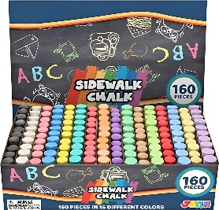  sidewalk chalk  Can be used for simple wayfinding along sidewalks or as an interactive, place-making device | 160 pieces | 1 | Click or tap here to enter text.
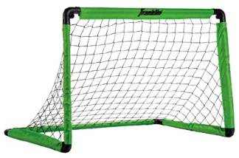  soccer goal, ball, pump  Interactive, place-making device. Works best with artificial turf and plastic barriers within parallel parking stalls. | 3’ | 2 | Click or tap here to enter text.
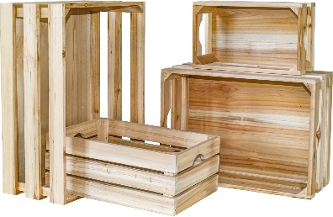  wooden crates  Can be used as planters, bookshelves, seating, etc. for parklets. | 4 crates  XL (16 x 12 x 6.5 in)  L (14 x 10 x 5.5 in)  M (12 x 8 x 4.75 in)  S (10 x 6 x 4 in) | 1 | Click or tap here to enter text.

